Enzyme Design
Enzyme name:esterase.fasta
Substrate:ligand.pdbqt
Code file
1.Coverterr.py file

import os
import subprocess

# Paths to your input files
receptor_pdb = os.path.abspath("../data/predicted_structure.pdb")
ligand_pdb = os.path.abspath("../data/Conformer3D_COMPOUND_CID_13243.sdf") # convert SDF → PDB first if needed

# Output files
receptor_pdbqt = os.path.abspath("../data/receptor.pdbqt")
ligand_pdbqt = os.path.abspath("../data/ligand.pdbqt")

# Path to MGLTools scripts
# Make sure prepare_receptor4.py and prepare_ligand4.py are in your PATH or specify full paths
prepare_receptor_script = "prepare_receptor4.py"
prepare_ligand_script = "prepare_ligand4.py"

# Convert receptor
subprocess.run([
"python", prepare_receptor_script,
"-r", receptor_pdb,
"-o", receptor_pdbqt,
"-A", "hydrogens"
])

# Convert ligand
subprocess.run([
"python", prepare_ligand_script,
"-l", ligand_pdb,
"-o", ligand_pdbqt,
"-A", "hydrogens"
])

print("Conversion complete!")
print(f"Receptor PDBQT: {receptor_pdbqt}")
print(f"Ligand PDBQT: {ligand_pdbqt}")

2.Docker-substrate.py

#from vina import Vina

# # Initialize Vina
#v = Vina(sf_name='vina')

# # Load enzyme and substrate
#v.set_receptor('../data/predicted_structure.pdb')
#v.set_ligand_from_file('../data/Conformer3D_COMPOUND_CID_13243.sdf')

# # Define docking box (center + size)
#v.compute_vina_maps(center=[10, 10, 10], box_size=[20, 20, 20])
#v.dock(exhaustiveness=8, n_poses=5)

# # Save results
#v.write_poses('../results/docking_output.pdbqt', n_poses=5)
#print("Docking completed. Results saved in ../results/docking_output.pdbqt")

import subprocess
import os

# Paths to receptor and ligand
receptor = os.path.abspath("../data/predicted_structure_receptor.pdbqt")
ligand = os.path.abspath("../data/ligand.pdbqt")
output = os.path.abspath("../results/docked.pdbqt")

# Docking box parameters (replace with your pocket coordinates)
center_x, center_y, center_z = 12.3, 25.7, 8.5
size_x, size_y, size_z = 20, 20, 20

# Run AutoDock Vina via subprocess
subprocess.run([
"vina",
"--receptor", receptor,
"--ligand", ligand,
"--center_x", str(center_x),
"--center_y", str(center_y),
"--center_z", str(center_z),
"--size_x", str(size_x),
"--size_y", str(size_y),
"--size_z", str(size_z),
"--out", output,
"--exhaustiveness", "8", # optional, default 8
"--num_modes", "9" # optional, default 9
])

print(f"Docking complete! Results saved at {output}")

3.Run-aplha fold.py

# import pymol
# from pymol import cmd

# # Start PyMOL in script mode
# pymol.finish_launching()

# # Load predicted enzyme structure and docked substrate
# cmd.load('../data/predicted_structure.pdb', 'enzyme')
# # cmd.load('../results/docking_output.pdbqt', 'substrate')
# cmd.load('../data/Conformer3D_COMPOUND_CID_13243.sdf', 'substrate')

# # Simple visualization commands
# cmd.show('cartoon', 'enzyme')
# cmd.show('sticks', 'substrate')
# cmd.color('cyan', 'enzyme')
# cmd.color('yellow', 'substrate')

# # Save a figure
# cmd.png('../results/enzyme_docking.png', width=1200, height=800)
# print("Visualization saved as enzyme_docking.png")

import pymol
from pymol import cmd

# Launch PyMOL in script mode
pymol.finish_launching()

# --- Load structures ---
# Load EstB enzyme structure (PDB format)
cmd.load('../data/predicted_structure.pdbqt', 'EstB')

# Load docked ligand from AutoDock Vina output
cmd.load('../results/docked.pdbqt', 'Ligand')

# --- Visualization setup ---
cmd.hide('everything')
cmd.show('cartoon', 'EstB')
cmd.color('cyan', 'EstB')

cmd.show('sticks', 'Ligand')
cmd.color('yellow', 'Ligand')

# --- Highlight binding pocket (within 4 Å of ligand) ---
cmd.select('Pocket', 'br. Ligand around 4.0')
cmd.show('sticks', 'Pocket')
cmd.color('salmon', 'Pocket')

# --- Optional: highlight catalytic residues (e.g., Ser105, His207, Asp236) ---
# cmd.select('Catalytic', 'resi 105+207+236')
# cmd.show('sticks', 'Catalytic')
# cmd.color('red', 'Catalytic')

# --- Zoom and render ---
cmd.zoom('Ligand')
cmd.png('../results/EstB_binding.png', width=1600, height=1200, dpi=300, ray=1)
print("✅ Render saved as ../results/EstB.png")

# --- Clean exit ---
cmd.quit()

4.test.py

import pymol2

with pymol2.PyMOL() as pymol:
cmd = pymol.cmd
# Load a PDB file (use your predicted_structure.pdb)
cmd.load('../data/predicted_structure_receptor.pdbqt', 'enzyme')
cmd.show('cartoon', 'enzyme')
cmd.color('cyan', 'enzyme')
# Save an image to check output
cmd.png('../results/EstB_binding.png', width=800, height=600)

print("PyMOL test complete! Check results/test_output.png")

5.visualize.py

import pymol2

def visualize(protein, ligand):
with pymol2.PyMOL() as pymol:
pymol.cmd.load(protein, "enzyme")
pymol.cmd.load(ligand, "substrate")
pymol.cmd.show("cartoon", "enzyme")
pymol.cmd.show("sticks", "substrate")
pymol.cmd.color("cyan", "enzyme")
pymol.cmd.color("yellow", "substrate")
pymol.cmd.png("../results/complex.png", width=800, height=600, dpi=300)

if __name__ == "__main__":
visualize("../data/predicted_structure_receptor.pdbqt", "../results/docked.pdbqt")

6.download_pdb.py
import os
import requests

pdb_id = "1CI8"
data_folder = "../data"
os.makedirs(data_folder, exist_ok=True)
output_path = os.path.join(data_folder, "predicted_structure.pdb")

url = f"https://files.rcsb.org/download/{pdb_id}.pdb"
headers = {"User-Agent": "Mozilla/5.0"}

try:
response = requests.get(url, headers=headers, timeout=30) # 30 sec timeout
response.raise_for_status()
with open(output_path, "wb") as f:
f.write(response.content)
print(f"✅ Downloaded {pdb_id}.pdb successfully.")
except requests.exceptions.RequestException as e:
print(f"❌ Failed to download: {e}")

- Requirement.doc
# Enzyme Project

#This project predicts the 3D structure of an enzyme, docks a substrate, and visualizes the complex.

## Workflow
#1. Place enzyme sequence in `data/esterase.fasta`
#2. Run AlphaFold: `python scripts/run_alphafold.py`
#3. Dock substrate: `python scripts/dock_substrate.py`
#4. Visualize: `python scripts/visualize.py`

## Requirements
#- AlphaFold or ColabFold
#- AutoDock Vina
#- PyMOL (open-source)
#- Python packages in `requirements.txt`

biopython
pymol
openbabel
vina
matplotlib
numpy
Project structure
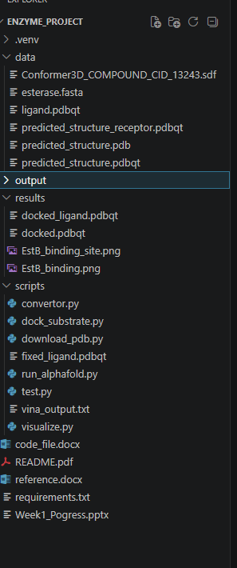
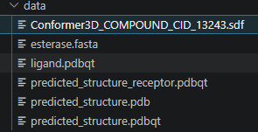
Output:

